THE SWEET POP

Capstone Project

Hello everyone!

My name is DivyaSri Emandi, let’s go and see the webpage which I developed using HTML, CSS, NODE.JS, SQL QUERIES for data storage using AXIOS, API’S, GET data, POST data, SEQUILIZE, .ENV (to store key’s), NODEMODULES, PGSTORE.

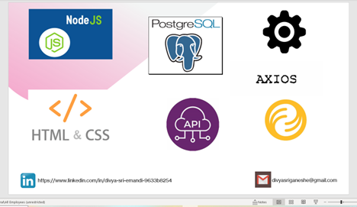

Where you can order online and pick up at store

